Digitalization Industrialization Standardization Collaboration

DISC DEXPI

Equinor – Aker BP – Aker Solutions - Aibel
Document title:
DISC DEXPI Symbol Definition Requirements

Document no.: | Rev.: | Page:
 | 0.1 | 1 of 18

DISC DEXPI Symbol Definition Requirements
Prepared for
DISC DEXPI Group
Prepared by
Pedersen, Tonia
Revision and Signoff Sheet

Change Record
Revision | Date | Reason for issue, key changes and or decisions | Prepared

Table of Contents
Change Record 3
Table of Contents 4
Overview 5
Purpose 5
Abbreviations 5
Process and Instrumentation Diagram Transfer 6
Overview 6
DrawIO symbol definition and svg export plugin 6
Overview 6
DrawIO symbol definition 6
Layer definition 6
‘Special’ symbol definition 6
Property definition 7
Dimension: 7
Connection Point: 7
Example file: 8
SVG Plug-in 8
Install 8
Configuration Options 8
Transfer Requirements 8
Symbols 10
ANNEX D: Symbol Rotation and mirroring - example 11
Rotation and Mirroring in DEXPI and Proteus 12
DEXPI 12
Proteus 13
ANNEX E: Signal conveying Line Types 13
ANNEX F: Valve Label Details 14
ANNEX G: Proteus Connection Points & Associations 15
Piping Connector 15
Instrument Connector 17

Overview

Purpose
This document provides the requirements for the DISC DEXPI project transfer of the P&ID between intelligent engineering systems using the DEXPI 2.0 standard.

Abbreviations

 | Description | Comment
DISC | Digitalization Industrialization Standardization Collaboration
DEXPI | Data Exchange in the Process Industry
P&ID | Process & Instrument Diagram
OPC | Off Page Connector
PIF | ProcessInstrumentFunctions
DEXPI XML | Working name for DEXPI 2.0 serialization format

Process and Instrumentation Diagram Transfer

Overview
The P&ID is a detailed graphical representation of the process flow and interconnection of the involved components, including piping, equipment, valves, instrumentation, and other process components.
Within the DISC DEXPI project the content of the P&ID has been broken down into the groups shown in the figure below; requirements regarding the transfer of each group are detailed in the sections below with a focus on the C01 example as redrafted by Aibel.

DrawIO symbol definition and svg export plugin

Overview
DrawIO (transitioning to diagrams.net) is an open source technology for building diagramming applications. The application has been chosen to produce the symbols used within the DISC DEXPI project.
In addition to the functionality provided as-is by the product it was also necessary to build an additional plug-in to provide bulk export of svg files with support for layers and dimensioning of the symbol.
The plug-in has been developed by pnb plants & bytes GmbH for Equinor
This document describes:
- The structure of the symbol definition with reference to use of layers, special symbols and property values
- How to install the plug-in
- The configuration settings for the plug-in.

DrawIO symbol definition
The symbol definition applied within the DISC DEXPI project provides the details needed to ensure that the CAD vendors can create each symbol using defined dimensions along with specified origin and connection point ordinates.

Layer definition
Each symbol is drafted with the following layers. Layers can be turn on/off as required to view the information pertaining to that layer. The case sensitive layer name is used within the configuration of the svg export plug-in to define which layer information shall be exported within the given export file. (Ref: Configuration Options)
- Symbol - the ‘raw’ symbol that will be drafted in the 2D CAD tool
- Origo - red circle designating the origin point of the symbol
- Label - general label placement and lookup code for attributes within the label
- Connection - green circles designating key connection points for the symbol
- Option # - ** optional layer(s) e.g., Option1 & Option2 displaying the symbol for different attribute settings (example: PV003A has 3 variants based on open/close settings)

‘Special’ symbol definition
The DISC DEXPI symbol legend uses special coloured circle symbols to identify origin and connection points: the centre of the circle provides the exact x,y ordinates of the origin / connection point. The use of coloured circles allows for both human and machine readable interpretation of this important information.
Origin (origo): Identified by red (RGB: 255,0,0 Hex: #ff0000) circle
Connection Points: Identified by green (RGB: 0, 255,0 Hex: #00FF00) circle

Property definition

Dimension:
Each symbol must be specified with a primary width and height dimension line. Properties of these lines are used within the svg export plugin to redimension the exported symbol to the correct size and add dimension lines to the output file via settings in the export configuration.
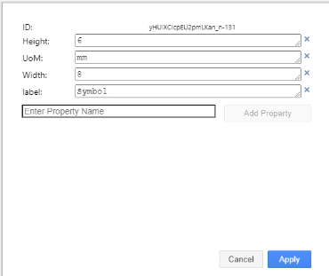
The dimension properties must be added to the Symbol layer.
Width: indicates primary width dimension as a numeric value
Height: indicates primary height dimension as a numeric value
UoM: Unit of Measure – currently only mm is supported.

Connection Point:
Connection point symbols are defined with the following properties to aid with validation of the DEXPI file and for use in other applications where dynamic connection lines are used.
Direction: Comma delimited list of values in degrees indicating the valid direction at which a connecting line can intercept the symbol. E.g. Direction: 180 indicates a connecting line can only intersect with the symbol from the left side of the symbol along the x-axis plane. 0º start point is given along the positive x-axis as shown.
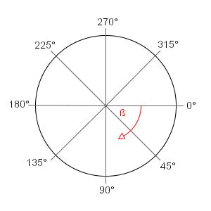
Figure 1: Connection line angle intercept value reference
LabelConnector: Indicates if the connection point allows label connection lines
PipingConnector: Indicates if the connection point allows piping connection lines
SignalConnector: Indicates if the connection point allows signal connection lines

Example file:

SVG Plug-in

Install
Execute following steps to install and use the plugin:
- Install draw.io (plugin is developed and tested with version 20.3.0)
- Start draw.io with the command line argument --enable-plugins
- You can add it to the link of draw.io
- The argument is needed to add the plugin and also to use the plugin
- Choose the plugin file in the open file dialog Extras|Plugins…|Add|External Plugins|Select File…
- Draw.io adds the plugin file to the folder: C:\Users$(User)\AppData\Roaming\draw.io\plugins
  - Add the file “svg_bulk_export.config.json” to this folder
- After restart of draw.io three new menu items should be added to the bottom of menu “Extras”
  - SVG bulk export – Single symbol
  - SVG bulk export – All symbols
  - SVG bulk export - Create zip file with folder structure' to menu 'Extras'

Configuration Options
Please refer to the readme.pdf file.

Transfer Requirements
Within the DISC DEXPI project it has been decided that the symbols shall form the basis of the mapping toward DEXPI to support the initial decision that we shall only transfer the graphical information from the P&ID in the DEXPI transfer file.
The DISC DEXPI project requires that each equipment object displayed on the P&ID shall be transferred within the DEXPI format with the required class mapping, symbol reference ID mapping, attribute mapping and association references to the piping / instrumentation systems as shown on the P&ID. The following sections provide details for the class and attribute mapping and implementation of the standard to reflect DISC process engineering drafting standards and symbols. Any additional rules or assumptions to be applied will also be noted in these sections.
General Requirement Details:
- PersistentID referencing shall be used to uniquely identify each class object. The context given within the PersistentID shall include a reference to the exporting application.
- DexpiCustomAttributes shall be used as the GenericAttributes ‘Set’ value within the Proteus export to group custom attributes that are defined within Error! Reference source not found.
- All Dexpi custom class definitions (DEXPI CustomObject subtypes) must use the DEXPI TypeName and TypeURI attributes as part of the class element transfer to provide the type details for the object. TypeName & TypeURI are provided in the symbol legend mapping.

Symbols
The DISC DEXPI symbol legend is based on Z004 NORSOK standard with some additions to support the DEXPI transfer, this project symbol legend is referred to as the DISC DEXPI symbol legend.
All symbols within this legend are mapped to a corresponding DEXPI class definition including any additional attributes to support the definition of the object.
A key feature of the DISC DEXPI symbol legend is the addition of a defined origo point for all symbols and the inclusion of the label as part of the overall graphic. A standard origo point definition across DISC will ensure correct placement of the symbol based on a single point element (x,y) for the shape in the transfer file.
The origo point placement is based on a few general rules:
- In-line components with 2 connectors the origo is placed on the center of the line transecting the symbol along the plane of the to-be connected pipeline to ensure ease of rotation on the pipeline and ease of substitution for intelligent attribute based symbols.
- In-line components with 3 or 4 connectors the origo is placed at the intersection point of the connectors
- In-line components with 1 connection point the origo is placed at the connection point
 |  |  |  |  |  |  |  |  | Label Details | Label Attribute(s) | Options
DEXPI ID | Graphic | Description | Rotation | Mirroring | ResizingX | ResizingY | TR1970 | Z004 | Symbol | A | 1
ND0011 | 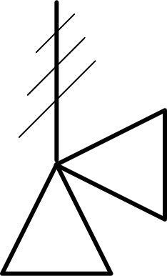 | Spring Actuated Safety Valve | Yes | Yes | No | No |  |  | IM005A
PV019A | 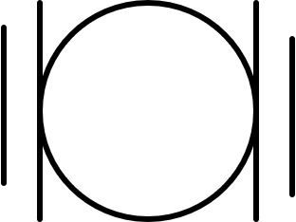 | Valve Ball | Yes | Yes | No | No | STLV008 | PV019A |  | <ObjectDisplayName> | ValvePosition = 'NC'

Requirement Details:
- SymbolRegistrationNumber attribute within the Shape element shall be used to provide the reference to the DISC DEXPI symbol reference ID.
- Name attribute of the Shape element shall be used as an internal file identifier to link the Shape symbol reference of the object to the Graphical representation instance of the object. Name is implemented in Proteus using ComponentName attribute.
- Location of the instance shall be given by the Shape Usage (Position / Reference) attributes for X & Y axiis. The X & Y points are the location reference to the origo of the symbol as defined in the symbol library for the project.
- Project shall use Label type ‘TagNameLabel’ for any item labels that are represented by a symbol e.g. for SafetyReliefValve.
  - Note: for most symbols the label is defined as part of the overall graphic. Ref Error! Reference source not found.
- Transformation definition for the symbol shall use the definitions and rules as defined within the DEXPI standard (This is described in Ref Error! Reference source not found. p. 19). Although any rotation shall be allowed and possible to transfer in the DEXPI file it is preferrable that only 0,90,180 & 270 deg anti-clockwise rotation of the symbol is used.
  - X-axis mirroring is provided for within DEXPI through the combination of attributes: ‘IsMirrored=True’ and ‘Rotation=180.0’ as per example (Ref: ANNEX D: Symbol Rotation and mirroring)
- Target application shall apply functionality to ensure that any text given as part of the overall symbol is displayed from left-to-right or bottom-to-top based on the rotation of the graphic.
- Target application shall use the rotation values from the transfer file and interpret the information to ensure graphical best fit with a focus on ensuring any symbol rotation transferred can be imported and displayed.
- All connection points shall be on the grid. This will ensure correct placement and management of the drawing connections for import.
- Symbol scaling shall be given by the ScaleX and ScaleY attribute of the DEXPI ShapeUsage element (implemented by the Proteus Scale element X and Y attributes)

ANNEX D: Symbol Rotation and mirroring - example
The following table shows the rotation and mirroring of an example symbol and demonstrates that mirroring the base symbol (shown in RED) on the Y-axis and then rotating 180º provides the same result as if the base symbol had been mirrored on the X-Axis. ** scaling before rotation.
Ref: Protues Example
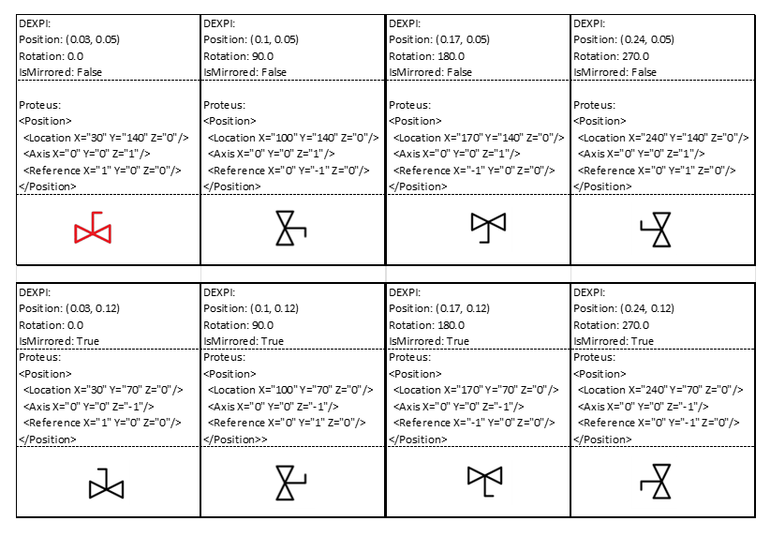
Figure 2: Symbol Rotation Attribute Example

Rotation and Mirroring in DEXPI and Proteus

DEXPI
- geometry unit: m (because SI base unit)
- axes and rotation like in SVG:
  - horizontal axis (x): left to right
  - vertical axis (y): top to bottom
  - rotation: in degrees, clockwise
- meaning of ShapeUsage attributes (note the order: in particular: scaling before rotation):
  - ScaleX, ScaleY: shape is scaled along x and y axis w.r.t. its origo (0, 0)
  - if IsMirrored: shape is mirrored at y axis (x=0)
  - Rotation: around (0, 0), in degrees, clockwise
  - Position: shape is translated such that its origo (0, 0) is translated to Position

Proteus
- geometry unit: given in <PlantInformation>, e.g., m or mm
- axes and rotation:
  - horizontal axis (x): left to right
  - vertical axis (y): bottom to top
  - rotation: in degrees, counterclockwise
- <Position> contains
  - <Location> = Position in DEXPI
  - <Axis> and <Reference> correspond to DEXPI Rotation and IsMirrored
    - <Axis> is rotation axis
we allow only rotation around third (z) axis:
      - <Axis X="0" Y="0" Z="1"/> means “not mirrorred”
      - <Axis X="0" Y="0" Z="-1"/> means “mirrored”
    - <Reference> is unit vector describing rotation of α around rotation axis:
      - <Reference X=”cos α”, Y=”sin α”, Z=0>
      - note that rotation axis has opposite direction if “mirrored”!

ANNEX E: Signal conveying Line Types
Refer to DISC DEXPI Symbol legend file Ref: Error! Reference source not found.

ANNEX F: Valve Label Details

The attributes available within valve labels shall be determined based on whether the valve symbol is used to show a manual valve or an on/off actuated or controlled valve. Attribute details for the valve label is defined in the symbol legend details (Ref: Error! Reference source not found.) using the attribute formats below.

- Manual Valves
A space character shall be used between the trim and lock mechanism attributes as shown.
<ObjectDisplayName>
<NominalDiameter><VDS>
<TrimType> <LockMechanism>

- On/Off Actuated or Controlled Valves
A space character shall be used between the trim and lock mechanism attributes as shown.
<NominalDiameter><VDS>
<TrimType> <LockMechanism>
Additional Notes:
- Valve Normal Position is no longer required to be shown in the label. Normal Position will be indicated by the symbol used e.g. black closed , white open
- Failure action is required to be shown in the label for the actuator if available Ref: Error! Reference source not found.
- “Barrier information is not required in the label as this will be shown as part of the graphic” referring to DIB valves (examples below) and “Barrier information” the DP and SR notations. The following DIB valves will be added to the DISC DEXPI symbol legend soon.
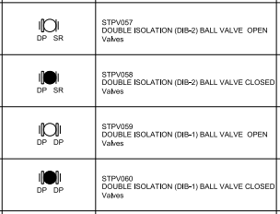
Figure 3: Valve Barrier variants

ANNEX G: Proteus Connection Points & Associations

Piping Connector
Within the piping system the piping connectors as defined by the conceptual DEXPI model have a 1:1 mapping with the graphical model. This allows the standard to simplify the export and NOT require the use of Associations to define relationships between conceptual elements, as this is already provided in Proteus export via graphical connections where:
- Node Type=’Process’ for piping ConnectionPoints Nodes
- Proteus XML Node element belonging to the ConnectionPoints XML node for the connected element represents the PipingNode conceptual element of the graphically represented element (has a SymbolReferenceID)
- The Proteus PipingNetworkSegment CenterLine child coordinates together with the coordinates of the nodes of the graphically connected elements provides the graphical connection information for the piping connectors.
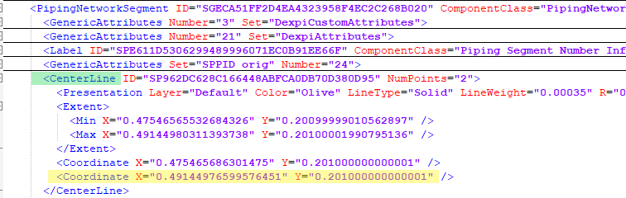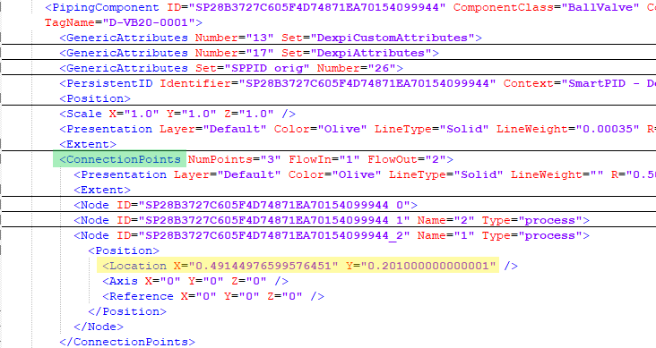

- Link between PipingNetworkSegment Connection From/To* Node & PipingNodeOwner: ConnectionPoints / Node**
* From/ToNode is not required where the connection is to a Nozzle
** based on node (zero-based) index of PipingNodeOwner / Connection Points
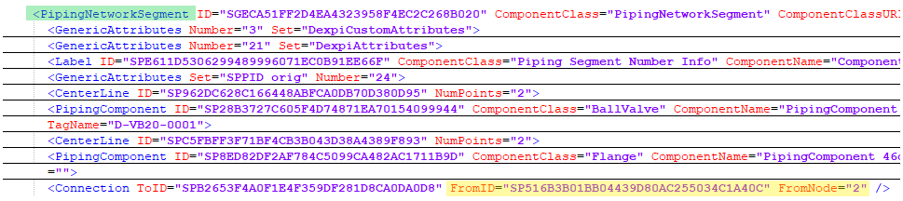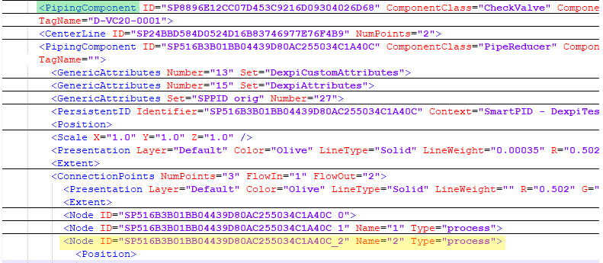

Instrument Connector
For Instrumentation connections the conceptual model as defined by DEXPI is not a 1:1 mapping to the graphical representation of the connection and therefor the standard requires the use of Associations to define relationships between conceptual elements in addition to the graphical representation of the connections where:
- Node Type=’Signal’ for instrument ConnectionPoints Nodes
- Proteus XML Node element belonging to the ConnectionPoints XML node for the connected element represents the graphical connection points for the graphically represented element (has a SymbolReferenceID)
- Proteus InformationFlow has associations ‘has logical end’ & ‘has logical start’ to define the conceptual model element connections.
  - Where the connected conceptual element will have the association ‘is logical end of’ or ‘is logical start of’
- The Proteus InformationFlow CenterLine child coordinates together with the coordinates of the nodes of the graphically connected elements provides the graphical connection information for the instrumentation connectors.
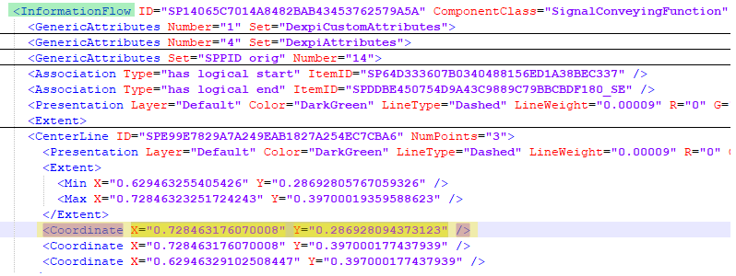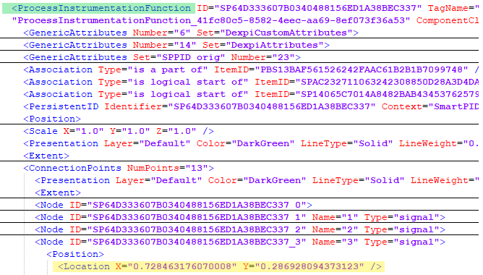

- When the Proteus InformationFlow has ComponentClass=’MeasuringLineFunction’ it is required that the related ProcessSignalGeneratingFunction class element shall have an association ‘is located in’ to define the conceptual model element sensing connection.
  - Where the SensingLocation conceptual element (Nozzle, PipingComponent or PipingNetworkSegmenet) will have the association ‘is the location of’

